Paper Title* (use style: paper title)

*Note: Sub-titles are not captured in Xplore and should not be used

line 1: 1st Given Name Surname   
line 2: *dept. name of organization   
(of Affiliation)*  
line 3: *name of organization   
(of Affiliation)*line 4: City, Country  
line 5: email address or ORCID

line 1: 4th Given Name Surname  
line 2: *dept. name of organization*  
*(of Affiliation)*  
line 3: *name of organization   
(of Affiliation)*line 4: City, Country  
line 5: email address or ORCIDline 1: 2nd Given Name Surname  
line 2: *dept. name of organization   
(of Affiliation)*  
line 3: *name of organization   
(of Affiliation)*line 4: City, Country  
line 5: email address or ORCID

line 1: 5th Given Name Surname  
line 2: *dept. name of organization   
(of Affiliation)*  
line 3: *name of organization   
(of Affiliation)*line 4: City, Country  
line 5: email address or ORCIDline 1: 3rd Given Name Surname  
line 2: *dept. name of organization   
(of Affiliation)*  
line 3: *name of organization   
(of Affiliation)*line 4: City, Country  
line 5: email address or ORCID

line 1: 6th Given Name Surname  
line 2: *dept. name of organization   
(of Affiliation)*  
line 3: *name of organization   
(of Affiliation)*line 4: City, Country  
line 5: email address or ORCID

*Abstract*— To address the challenges of high labor costs, lengthy detection periods, and insufficient information in current environmental monitoring systems, this paper proposes a water quality monitoring system based on LoRa, Cellular Network, and Machine Learning (ML) with low-power Internet of Things (IoT) technology. The system features data storage, a web application user interface, long-distance data transmission, dynamic monitoring, AI prediction, data visualization, and pollution alarms for the distributed deployment of multisensory node information (pH, turbidity, total dissolved solids, and water temperature). The system utilizes an Arduino Nano equipped with various water quality sensors to collect real-time water quality parameters. The collected data is then packaged and sent to an ESP32, which collaborates with a GSM SIM800C module to function as a remote gateway using LoRa technology. The data is stored on an SD card. The gateway bridges the LoRa link to an IP link, forwarding the water quality information to a Firebase Cloud server. Finally, end-users can monitor and control water quality through a web/app platform. In the experiments after testing on 3 different lakes in National Polytechnic Institute of Cambodia results show that the system has a good performance in terms of real time data and acquisition accuracy, data transmission reliability, Pollution alarm success rate. The average relative errors of water temperature, pH, turbidity, and conductivity are 0.31%, 0.28%, 3.96%, and 0.71%, respectively. In addition, the signal reception strength of the system within 2 km is better than -81 dBm, and the average packet loss rate is only 94%. In short, the system’s high accuracy, high reliability, long-distance characteristics meet the needs of large area water quality monitoring and the prediction having more accurately than we expect as our data have been train many times so the accuracy are 63%.

Keywords—Internet of Things, Artificial Intelligent, Website Application, Cellular Network, Water Quality, LoRa Technology.

# Introduction (*Heading 1*)

Water is the natural resource for the survival of mankind and is of great significance to human production and life. In recent years, with the vigorous development of mankind, domestic sewage, production wastewater and various wastes discharged from agricultural production are directly discharged into water bodies without treatment, which causes serious pollution of rivers, lakes and groundwater, further leads to serious deterioration of the water quality in the area, affects the normal life of residents and causes ecological unbalance. Therefore, The quality of drinking water is important to human health and to provide a safe drinking water supply is one of the main objectives of Cambodian National Policy. Cambodia is located in Southeast Asia between latitudes 10° and 15° N. and longitudes 102° and 108° E. The country covers an area of 181,035 km². Cambodia is bordered by Vietnam in the east and southeast, the Lao PDR in the north and by Thailand in the north and northwest. To the southwest the country has a seacoast on the Gulf of Thailand. In Cambodia, both surface water and groundwater are used for drinking water. The Mekong River and the Tonle Sap Lake are the predominant sources of surface water, with the Mekong serving the east and the Great Lake serving the more westerly populations. The river system provides abundant and good quality drinking water. Applying the WHO standards, these resources require only basic treatment including disinfection. Provincial towns generally have access to surface water from the river systems in unlimited quantities. Although Cambodia has abundant water resources but the accelerating pace of industrial development and population growth in recent decades have affect the quality of water. Since Cambodia is local in Mekong River, In the recognizing that sustainable development of water resources of the LMB will not be possible without effective management of water quality, the MRC Member Countries (MCs) agreed to establish a Water Quality Monitoring Network (WQMN) with the specific objective of detecting changes in the Mekong River water quality and ensuring that preventive and remedial actions are taken if any changes are detected. The routine monitoring and reporting of water quality are the main functions of the WQMN, which was established in 1985 with a funding support from the Swedish International Development Agency (Sida). In 2018 Forty-eight (48) stations were monitored by the WQMN in 2018. There 11 stations in Lao PDR, 8 Station in Thailand, 19 Station in Cambodia, 10 Station in Viet Nam. For consistency, the MCs have agreed to carry out the sampling and monitoring of water quality on a monthly basis between the 13th and 18th day of each month. In order to monitoring the quality MCR…………………………………………………………………………………………………………………………………………………………..

# Architecture Design

The NPIC lake water quality monitoring system proposed by this research consists of four parts: perception layer, transmission layer, Machine Learning, platform layer, and application layer. The system mainly realizes the functions for distributed collection of water quality data, node positioning, remote transmission, data storage, remote monitoring and AI Prediction. The system architecture diagram is shown in Figure 1.

The lake water quality monitoring system proposed by this research consists of four parts: perception layer, transmission layer, platform layer, and application layer. The system mainly realizes the functions for distributed collection of water quality data, node positioning, remote transmission, data storage, and remote monitoring. The system architec- ture diagram is shown in Figure 1.

The water quality monitoring node in this system is based on LoRa technology. The node is distributed in the target water area and consists of a control unit, a water temperature-pH composite sensor, a turbidity sensor, a con- ductivity sensor, a power management module, and a LoRa Radio Frequency (RF) transceiver module. On the one hand, the LoRa node collects various water quality parameters such as water temperature, pH, turbidity, and conductivity by sensors. Finally, the information is packaged and sent to the transport layer by the LoRa communication module. In the transport layer, in order to cope with high PLR (packet loss rate) that may be caused by the data access of large-scale nodes, this research has extended eight RFM92 baseband chips for the RFM92 baseband chip of the LoRa gateway. In this way, the symmetry of uplink and downlink eight channels is realized, and a reliable trans- mission link is provided for user data. The third layer is the platform layer, which is responsible for aggregating terminal data forwarded by the Gateway. And according to the diﬀerent data types, it is stored in the Firebase database in an orderly manner and provides support for the monitoring application system to realize specific business functions. The application layer is the fourth layer. The monitoring system completes data analysis, query, visualization, local storage, pollution alarm, AI Prediction and other functions by calling the data processing interface provided by the Web/App platform.

The system has a clear hierarchy from bottom to top. The terminal node of the perception layer obtains detailed data. The transport layer puts forward countermeasures in the face of the large-scale data access problem of distributed nodes. The platform layer provides reliable support for user applications. The monitoring system at the application layer is fully functional.

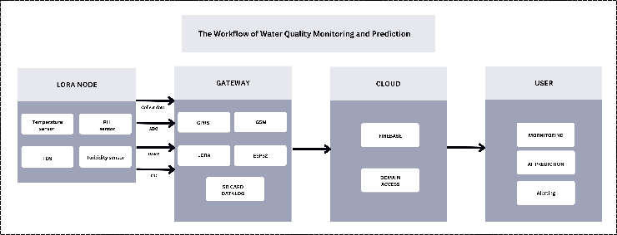

Figure : System Architecture Diagram

# Methodology

## Node Design

The water quality monitoring node is located in the sensing layer of monitoring system and is distributed in the moni- toring target water area. Each node has its unique ID num- ber and communicates with the gateway by diﬀerent channels. It can be divided into four parts for design: main control board, water quality selection, power management module design, and LoRa RF unit Selection. Among them, the design of the main control board and LoRa RF unit is the most critical, and main control board dispatches water quality sensor for data collection. LoRa RF unit is responsible for data interaction with the gateway.

### Main Control Board.

### The frame diagram of the main control board design is shown in Figure 2. Considering the complex water quality environment, multidimensional water quality data is collected for comprehensive analysis. For this reason, pH Sensor, TDS Sensor, Temperature Sensor, Turbidity Sensor are selected to Measures the acidity or alkalinity of a solution, Measures the Total Dissolved Solids in water, which indicates water quality, Measures the temperature of the environment or liquid, Measures the cloudiness or haziness of a liquid, which can indicate the presence of suspended particles of the target water area. The main microcontroller adopts Arduino NANO produced by Arduino. The Arduino Nano is based on the ATmega328 microcontroller, a popular choice for many microcontroller applications due to its balance of performance, power efficiency, and ease of programming. This chip has rich peripheral interfaces such as, UART, ADC, I2C, GPIO, and SPI. And the built-in 32 kBytes Flash and 2 kBytes RAM can meet the access requirements of sensors and LoRa communication modules. Moreover, has low power consumption and is suitable for long-term monitoring needs. The chip mainly completes data collection, processing, and sends and receives data packets by the RFM95 unit.

### Water Quality Sensor

This research conducted a more comprehensive analysis of water quality parameters such as water temperature, pH, turbidity, and conductivity. The selected sensor modules are shown in Figure 3. Among them, in water temperature-pH composite sensor, we use BNC interface and E-201-C type pH compos- ite electrode. In addition, the sensor has expanded DS18B20 temperature sensor interface. On the one hand, it can read the water temperature parameters, and on the other hand, it can compensate pH detection value to improve the accu- racy. The sensor uses 5 V working voltage and analog out- put. The working temperature is between 0-60°C, the measuring range is 0-14PH, and the response time is less than or equal to 1 minute.

The model of turbidity sensor selected in this study is TSW-30. The sensor comprehensively judges the turbidity by light transmittance and scattering rate in the target solu- tion. The sensor can output both analog and digital signals at the same time, and the working voltage is 5 V. The standard operating temperature is between -20°C and 90°C, and the detection response time is less than 500 ms.

Conductivity reflects the electrolyte concentration of the measured solution and is an important parameter to mea- sure the water quality. DJS-1 conductivity electrode in con- ductivity sensor is used for water quality monitoring. The sensor uses a 5 V supply voltage and a 0 ~ 3.4 V analog out- put. The working temperature is between 0 and 40°C, and the supported measurement range is 0-20 mS/cm.

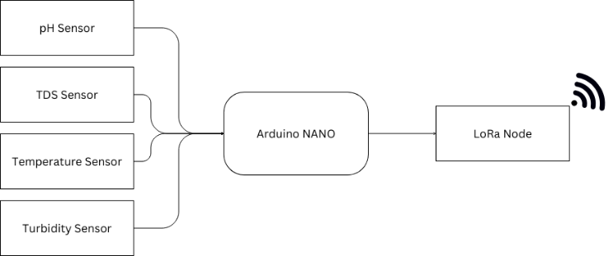

Figure . Node Design Block Diagram

### Power Management

The system begins with an MPPT (Maximum Power Point Tracking) solar charger that maximizes the energy harvested from solar panels to charge a 3.7V battery. This battery serves as the primary power source, supplying energy to a boost converter that elevates the voltage to appropriate levels required by the connected components. The Arduino Nano is central to this setup, receiving power from the boost converter and distributing it to different sensors and modules. Specifically, the Arduino Nano splits into two branches: one provides a regulated 5V to power the pH, TDS, turbidity, and temperature sensors, ensuring accurate data collection, while the other branch powers another Arduino Nano at 3.3V, which is dedicated to the LoRa Node. The LoRa Node is responsible for transmitting collected sensor data over long distances, thereby facilitating remote monitoring. This hierarchical power distribution ensures that each component operates within its required voltage specifications, enhancing the overall efficiency and reliability of the system. The frame of LoRa Node Power Management in Figure 3.

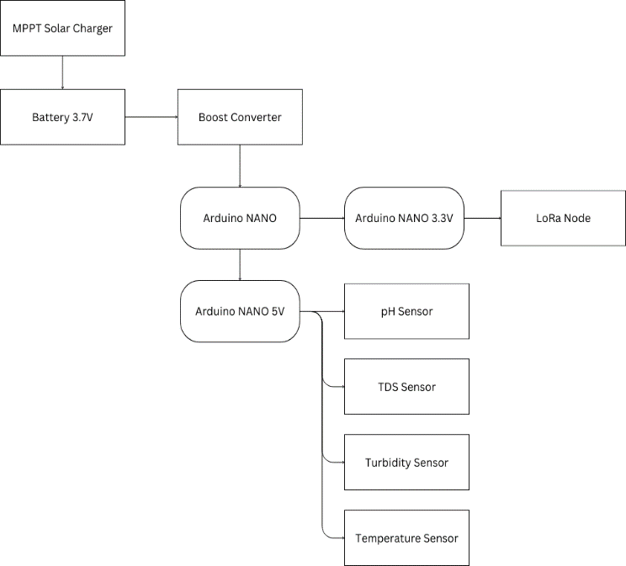

Figure Power Management in LoRa Node

### LoRa RF Unit Selection

The LoRa RFM96 module, built upon Semtech's SX1276 transceiver chip, epitomizes the pinnacle of long-range communication technology, boasting exceptional range and minimal power consumption. Its key features include adaptive data rate adjustment, ensuring efficient bandwidth utilization, and robust encryption algorithms for secure data transmission. Despite its advanced capabilities, the module maintains a compact form factor, making it versatile for integration across various applications. From smart agriculture to asset tracking and wildlife conservation, the LoRa RFM95 module finds widespread use in diverse industries, facilitating real-time monitoring and control over extensive distances. As the demand for efficient, long-range communication solutions continues to rise, the LoRa RFM95 module stands at the forefront, driving innovation and enabling connectivity in the IoT era.

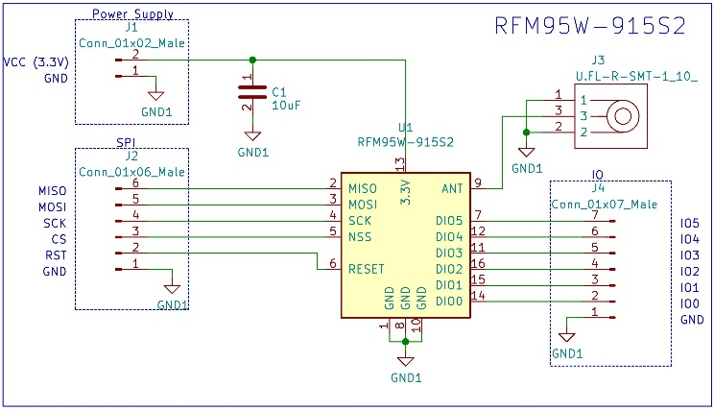

Figure Schematic of RFM95

## Gateway Design

The Gateway is the main system and every important for the whole process. which orchestrates a comprehensive network of peripherals and modules to enable robust data collection, processing, storage, display, and communication. At its core, the ESP32 leverages its built-in Wi-Fi and Bluetooth capabilities, augmented by external modules to enhance functionality. An SD card module provides extensive local storage capacity, ensuring that all sensor data, whether raw or processed, is securely logged even in the absence of network connectivity. This feature is critical for applications requiring historical data analysis or continuous monitoring without data loss. The Real-Time Clock (RTC) module, typically interfaced via I2C, ensures precise timekeeping, allowing the ESP32 to timestamp all data accurately, which is vital for chronological data integrity in time-sensitive applications. For real-time feedback and local monitoring, an OLED display, also connected via I2C, provides immediate visual representation of current sensor readings, system status, and other critical information. Communication is a cornerstone of this system, facilitated by multiple channels to ensure versatility and reliability. The GSM module, interfaced through UART, enables cellular communication, allowing the system to transmit data and receive commands even in remote locations where Wi-Fi infrastructure is unavailable. This capability is essential for scenarios like remote environmental monitoring or agricultural applications where cellular coverage is the primary means of connectivity. Additionally, the LoRa Gateway provides long-range, low-power wireless communication, utilizing either UART or SPI interfaces. This module is particularly beneficial for transmitting data over vast distances in rural or expansive deployment areas, such as in smart agriculture or environmental monitoring networks. The ESP32 processes sensor data, displays it on the OLED screen, stores it on the SD card, and transmits it via the most suitable communication channel available—Wi-Fi, GSM, or LoRa—ensuring that the data reaches the central server or cloud platform for further analysis and action. This versatile setup is well-suited for a multitude of applications, including water quality monitoring, where it can track pH, TDS, Turbidity and Temperature.

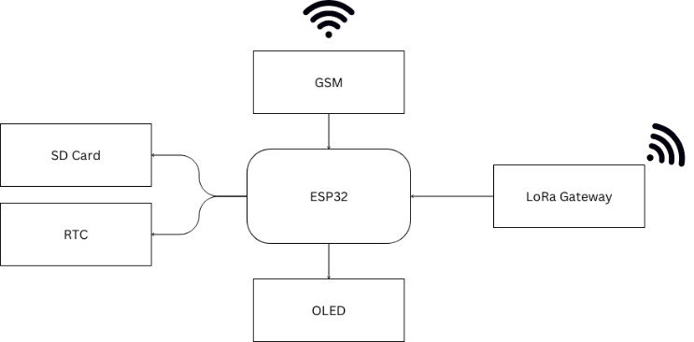

Figure Gateway Block Diagram

### Power Management LoRa Gateway

The 12V power supply provides power to the voltage regulator. The voltage regulator converts the 12V input voltage to 5V and 3.3V output voltages. The 5V output voltage is used to power the ESP32 microcontroller, which is the main component of the system and is responsible for controlling all of the other components in the system. The SD card is used to store data that is collected by the LoRa Gateway. The real-time clock (RTC) is used to keep track of the time.

The 3.3V output voltage is used to power the LoRa module (RFM96), which is used to communicate with other LoRa devices. The OLED display (if used) is used to display information about the system, such as the current time, signal strength, and data usage. The GSM module (if used) is used to provide cellular connectivity to the system, which can be useful for troubleshooting or for providing a backup connection if the LoRaWAN network is unavailable.

This power management system is designed to provide efficient and reliable power to the LoRa Gateway. The voltage regulator ensures that the different components of the system receive the correct voltage. The use of low-power components, such as the ESP32 microcontroller and the RFM96 LoRa module, helps to conserve battery life. Additionally, the system can be powered by a variety of sources, such as a solar panel or a battery, which makes it suitable for deployment in remote locations.

The frame of LoRa Gateway Power Management in Figure 6

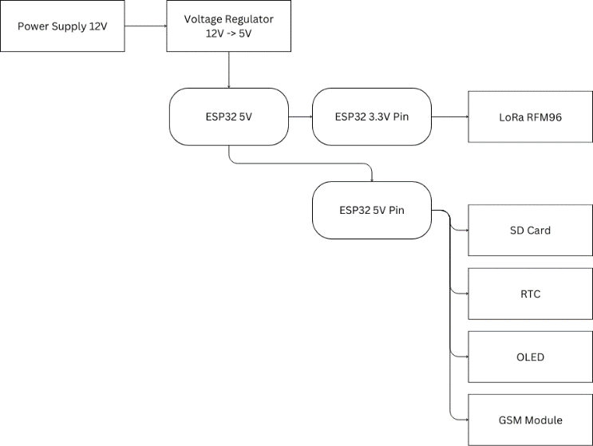

Figure Power Management of LoRa Gateway

## Transport Layer Design

The transmission layer design of this system includes com- munication networking architecture and LoRa gateway. The communication networking architecture of this research chooses the star networking mode, and the network topol- ogy is shown in Figure 7. The star network is the simplest network structure with the lowest latency.

LoRa Node will send the data from sensor to Gateway within 10 second per node. So, the gateway will get the data in real time from each LoRa Node in every 10 second. In others way LoRa gateways can be built by themselves without relying on operators. LoRa gateway is arranged in the water quality monitoring system. It is at the core of LoRa star network and is an information exchange bridge between data terminals and servers. The gateway and cloud server are connected by standard IP. At the same time, it also supports functions such as node access control, node upload data packet analysis, uplink and downlink resource allocation and scheduling, user data encrypted transmission, and software remote upgrades.

Figure LoRa Node Star Network Architecture

## Machine Learning Design

## Platform Web/App Design

The platform of this research is Web/App. Which is easy for using with Computer and Mobile and Easy to adopt at any problems. The remote monitoring system of application layer communicates with cloud platform by HTTP protocol to obtain the data of underlying equipment and realize data real-time monitoring, equipment management, water quality alarm, historical data viewing, AI prediction of the water condition and other functions. As shown in Figure 8 the user water quality monitoring system searches by node ID number and sensor name and can monitor the real-time data collected by sensors under each node. Moreover, it can view the historical data curve collected by nodes. The water quality monitoring alarm is mainly realized by triggers in the application soft- ware. When the trigger detects that node collection value exceeds the threshold range preset by administrator, it will be sent out an alarm message. The alarm information contains abnormal node ID and the water quality parameter. Moreover, the Prediction of the water condition also shown in the Dashboard so that the users can easily avoid the pandemic or problem in the water area.

**

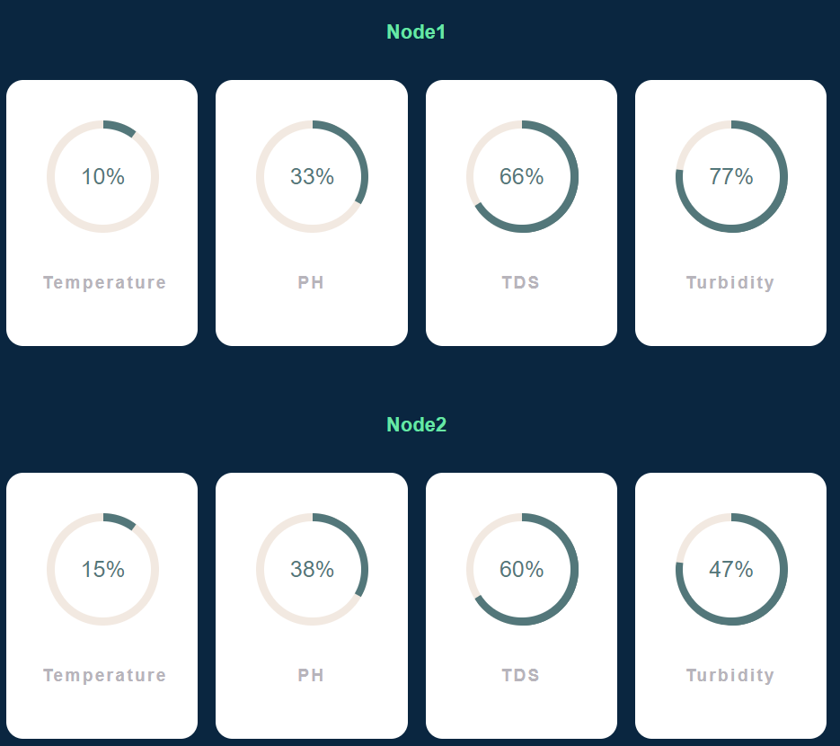

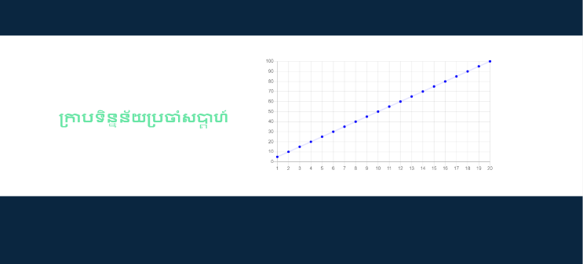

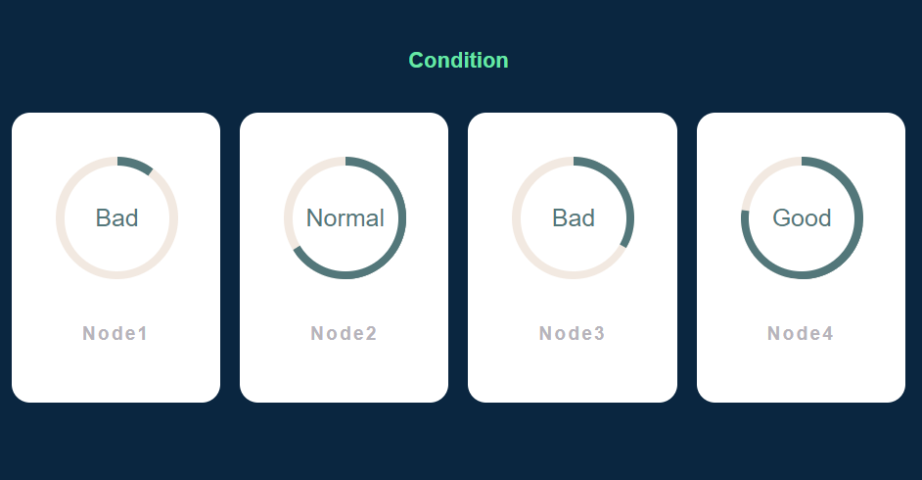

Figure Monitoring Dashboard

Table Real Time Monitoring on Node 1

|  |  |  |  |  |
| --- | --- | --- | --- | --- |
| Time | Temp | TDS | Turbidity | pH |
| 17:11.6 | 28.5 | 2.21 | 101.92 | 3.81 |
| 17:24.9 | 28.5 | 2.2 | 112.63 | 4.94 |
| 17:25.4 | 28.5 | 2.2 | 112.63 | 3.8 |
| 17:26.8 | 28.5 | 2.27 | 102.99 | 3.7 |
| 17:27.4 | 28.5 | 2.27 | 102.99 | 3.67 |
| 17:27.8 | 28.5 | 2.22 | 102.03 | 3.67 |
| 17:28.2 | 28.5 | 2.22 | 102.03 | 3.67 |
| 17:28.7 | 28.5 | 2.22 | 101.93 | 3.67 |

Table Real Time Monitoring on Node 2

|  |  |  |  |  |
| --- | --- | --- | --- | --- |
| Time | Temp | TDS | Turbidity | pH |
| 19:08.8 | 28.62 | 2.22 | 102.77 | 3.2 |
| 19:09.6 | 28.62 | 2.19 | 101.8 | 3.16 |
| 19:10.4 | 28.62 | 2.19 | 101.8 | 3.16 |
| 19:11.1 | 28.62 | 2.19 | 101.7 | 3.18 |
| 19:11.8 | 28.62 | 2.19 | 101.7 | 3.14 |
| 19:12.6 | 28.62 | 2.34 | 101.69 | 3.15 |
| 19:13.2 | 28.62 | 2.34 | 101.69 | 3.18 |
| 19:14.0 | 28.62 | 2.08 | 101.69 | 3.14 |
| 19:14.7 | 28.68 | 2.08 | 101.69 | 3.15 |

# Experiment and results

## Data Collection Accuracy Experiment.

. In order to verify the system accuracy of data monitoring, we chose to conduct field tests in NPIC Lake of National Polytechnic Institute of Cambodia. The lake covers an area of about 0.3 square kilometers, and there are a large number of egrets on the island in the lake center. It has the functions of receiving rainwater, aquaculture, and landscape ecology and has great water environmental protection value.

In the experiment, 3 Nodes are distributed to diﬀerent locations in NPIC Lake to obtain multiple types of water quality parameters in real time. In order to verify the all- weather monitoring ability of system under various meteorological conditions, we measure every minute under the rainy season as well as morning, noon, and night. Since we need the data for training our model to deploy in our platform. While the specific campus location of the gateway remains undisclosed, the diagram meticulously reveals the varying distances between each node and the central hub. Node 1, acting as the closest sentinel, sits a mere 0.2 kilometers away from the gateway, ensuring a strong and reliable connection for data transmission. Node 2, venturing slightly further afield, is positioned at a distance of 0.6 kilometers from the gateway. This measured placement still allows for effective communication, though signal strength may differ compared to Node 1. Finally, Node 3 emerges as the farthest outpost, located a challenging 1.09 kilometers from the gateway. This extended range will test the limits of the LoRa network's ability to transmit and receive data effectively, providing valuable insights into the technology's reach and potential limitations under such circumstances. The careful positioning of these nodes allows researchers to analyze the impact of distance on signal strength and data transmission efficiency within a LoRa network. The distance from each node to gateway shown in Figure 9.

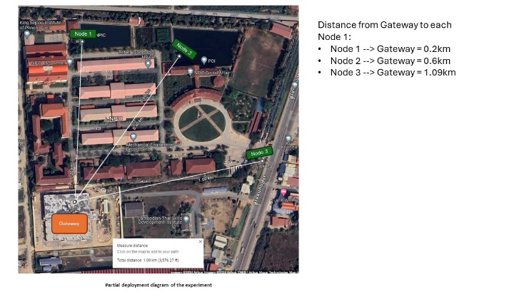

Figure Distance of Each Node to Gateway Experiment

## Communication Quality Experiment

## Prediction Accuracy Experiment

## Web/App Experiment

Headings, or heads, are organizational devices that guide the reader through your paper. There are two types: component heads and text heads.

Component heads identify the different components of your paper and are not topically subordinate to each other. Examples include Acknowledgments and References and, for these, the correct style to use is “Heading 5”. Use “figure caption” for your Figure captions, and “table head” for your table title. Run-in heads, such as “Abstract”, will require you to apply a style (in this case, italic) in addition to the style provided by the drop down menu to differentiate the head from the text.

Text heads organize the topics on a relational, hierarchical basis. For example, the paper title is the primary text head because all subsequent material relates and elaborates on this one topic. If there are two or more sub-topics, the next level head (uppercase Roman numerals) should be used and, conversely, if there are not at least two sub-topics, then no subheads should be introduced. Styles named “Heading 1”, “Heading 2”, “Heading 3”, and “Heading 4” are prescribed.

## Figures and Tables

#### Positioning Figures and Tables: Place figures and tables at the top and bottom of columns. Avoid placing them in the middle of columns. Large figures and tables may span across both columns. Figure captions should be below the figures; table heads should appear above the tables. Insert figures and tables after they are cited in the text. Use the abbreviation “Fig. 1”, even at the beginning of a sentence.

1. Table Type Styles

| Table Head | Table Column Head | | |
| --- | --- | --- | --- |
| Table column subhead | Subhead | Subhead |
| copy | More table copya |  |  |

1. Sample of a Table footnote. (*Table footnote*)
2. Example of a figure caption. (*figure caption*)

Figure Labels: Use 8 point Times New Roman for Figure labels. Use words rather than symbols or abbreviations when writing Figure axis labels to avoid confusing the reader. As an example, write the quantity “Magnetization”, or “Magnetization, M”, not just “M”. If including units in the label, present them within parentheses. Do not label axes only with units. In the example, write “Magnetization (A/m)” or “Magnetization {A[m(1)]}”, not just “A/m”. Do not label axes with a ratio of quantities and units. For example, write “Temperature (K)”, not “Temperature/K”.

##### Acknowledgment *(Heading 5)*

The preferred spelling of the word “acknowledgment” in America is without an “e” after the “g”. Avoid the stilted expression “one of us (R. B. G.) thanks ...”. Instead, try “R. B. G. thanks...”. Put sponsor acknowledgments in the unnumbered footnote on the first page.

##### References

The template will number citations consecutively within brackets [1]. The sentence punctuation follows the bracket [2]. Refer simply to the reference number, as in [3]—do not use “Ref. [3]” or “reference [3]” except at the beginning of a sentence: “Reference [3] was the first ...”

Number footnotes separately in superscripts. Place the actual footnote at the bottom of the column in which it was cited. Do not put footnotes in the abstract or reference list. Use letters for table footnotes.

Unless there are six authors or more give all authors’ names; do not use “et al.”. Papers that have not been published, even if they have been submitted for publication, should be cited as “unpublished” [4]. Papers that have been accepted for publication should be cited as “in press” [5]. Capitalize only the first word in a paper title, except for proper nouns and element symbols.

For papers published in translation journals, please give the English citation first, followed by the original foreign-language citation [6].

1. G. Eason, B. Noble, and I. N. Sneddon, “On certain integrals of Lipschitz-Hankel type involving products of Bessel functions,” Phil. Trans. Roy. Soc. London, vol. A247, pp. 529–551, April 1955. *(references)*
2. J. Clerk Maxwell, A Treatise on Electricity and Magnetism, 3rd ed., vol. 2. Oxford: Clarendon, 1892, pp.68–73.
3. I. S. Jacobs and C. P. Bean, “Fine particles, thin films and exchange anisotropy,” in Magnetism, vol. III, G. T. Rado and H. Suhl, Eds. New York: Academic, 1963, pp. 271–350.
4. K. Elissa, “Title of paper if known,” unpublished.
5. R. Nicole, “Title of paper with only first word capitalized,” J. Name Stand. Abbrev., in press.
6. Y. Yorozu, M. Hirano, K. Oka, and Y. Tagawa, “Electron spectroscopy studies on magneto-optical media and plastic substrate interface,” IEEE Transl. J. Magn. Japan, vol. 2, pp. 740–741, August 1987 [Digests 9th Annual Conf. Magnetics Japan, p. 301, 1982].
7. M. Young, The Technical Writer’s Handbook. Mill Valley, CA: University Science, 1989.

**IEEE conference templates contain guidance text for composing and formatting conference papers. Please ensure that all template text is removed from your conference paper prior to submission to the conference. Failure to remove template text from your paper may result in your paper not being published.**